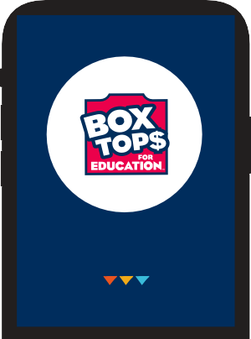
NO MORE CLIPPING. ALL YOU NEED IS YOUR SMARTPHONE.
HERE’S HOW IT WORKS:
EARN CASH FOR OUR SCHOOL

The NEW and improved Box Tops mobile app uses
NO MORE CLIPPING
YOUR RECEIPT
SCAN
BTFE.COM
SEE HOW AT

state-of-the-art technology to scan your store receipt, find participating products and instantly add Box Tops to our school's earnings online.
LOOK FOR THE NEW LABEL:



RECEIPT

BOX TOPS PRODUCTS
BUY
You can find Box Tops on hundreds of products throughout the store.

YOUR RECEIPT
Use the app to snap a photo of your receipt within 14 days of purchase.
SCAN

CASH FOR OUR SCHOOL
Box Tops earnings are identified and automatically updated at BTFE.com.
EARN

You do not need to clip or send Box Tops labels to school.

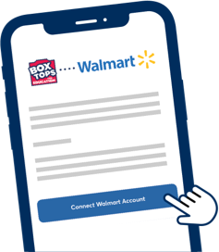BOX TOPS + WALMART
When you connect your Box Tops and Walmart accounts, you can earn when you shop at Walmart — no scanning required. All you have to do is pay with the saved payment method in your Walmart wallet and the Box Tops app will identify participating products and automatically credit earnings to your school.

SEE PRODUCTS & LEARN MORE ABOUT THE BOX TOPS APP AT BTFE.COM
© General Mills
THE ALL-NEW BOX TOPS IS HERE!
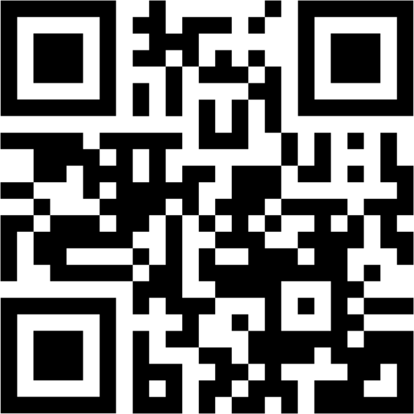
DOWNLOAD THE APP:

