List of Private Summer Tutors at Holy Trinity
**The individual tutors and tutoring services included are simply a list of area resources. Their inclusion here does not constitute or imply the endorsement of Holy Trinity Parish School. It is the parents’ responsibility to obtain references, cost structure,
policies, etc. from the tutors listed, and select a provider who is a good fit for your child and needs.**
Kelley Powers  Kindergarten Teacher  Masters Degree  Tutors Grades K-2, reading & math  kpowers@ht-school.org | Julie Melder  Kindergarten Teacher  Masters Degree and Wilson Certified  Tutors Grades K-5 in Reading & Math  jmelder@ht-school.org | Jennifer Mullins  1st Grade Instructional Assistant  Master’s Degree  1st-3rd  Jmullins@ht-school.org
Allie Blackburn  2nd Grade Teacher  Masters Degree in Education  Tutors grades 2-5, all subjects  ablackburn@ht-school.org | Nikki Allgeier  2nd grade Instructional Assistant  Associates degree in science  Tutors K-4 all subjects  nallgeier@ht-school.org | Kathleen Braun  3rd Grade Teacher  Masters in Elem. Ed.  Rank 1 Cert. in Wilson Reading  Tutors Reading Grades 2-4  kbraun@ht-school.org
Hannah Graham  3rd Grade Teacher  Masters in Teaching  Reading and Math 2nd through 4th  hgraham@ht-school.org | Tiffany Horner  4th Grade Math Teacher  Masters Degree  Tutors Grades incoming 3-7, all subjects  thorner@ht-school.org | Mary French  6th Grade Social Studies/Religion  Masters Degree  Tutors Grades 3-8, all subjects  mfrench@ht-school.org
Eric Awbrey  7th/8th Grade Social Studies  Masters Degree  Tutors Grades 1-7 all subjects  eawbrey@ht-school.org | Claudia Alfaro  Spanish Teacher  Certified ESOL Teacher  Tutors Grades 4-8, Spanish  calfaro@ht-school.org | D.Dee Hill  Librarian  Certified in Early Childhood-4th  Tutors Grades K-8, all subjects  dhill@ht-school.org
Catherine Barton  Rank 1, Masters in Reading, Masters in Learning and Behavior  Disorders, Retired FCPS teacher 28 years classroom experience  Orton-Gillingham Trained  Tutors K-3 in reading  cbarton@ht-school.org | Ashley Davenport  Director of Student Activities  Masters Degree, Certified in Elem. Ed. and Spec. Ed. – Learning and Behavior Differences;  Tutors Gr. 2-8 & homework asst.  adavenport@ht-school.org | Theresa Bradshaw  Jr. High Instructional Assistant  Bachelors of Science in Occupational Therapy  Tutors Grades 1-6, all subjects  tbradshaw@ht-school.org
OCCUPATIONAL THERAPY  Ashley Berger  Occupational Therapist - HT Clifton School  Private Occupational Therapy Sessions - Grades PreK-8th grade  aberger@ht-school.org | OCCUPATIONAL THERAPY  Peyton Bishop  Occupational Therapy Assistant - HT Clifton School.  Private Occupational Therapy Sessions - Grades PreK-8th grade  pbishop@ht-school.org
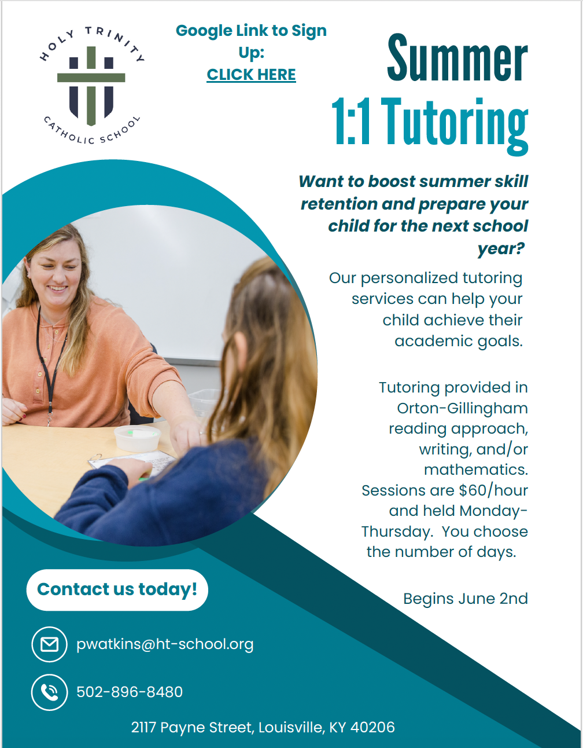
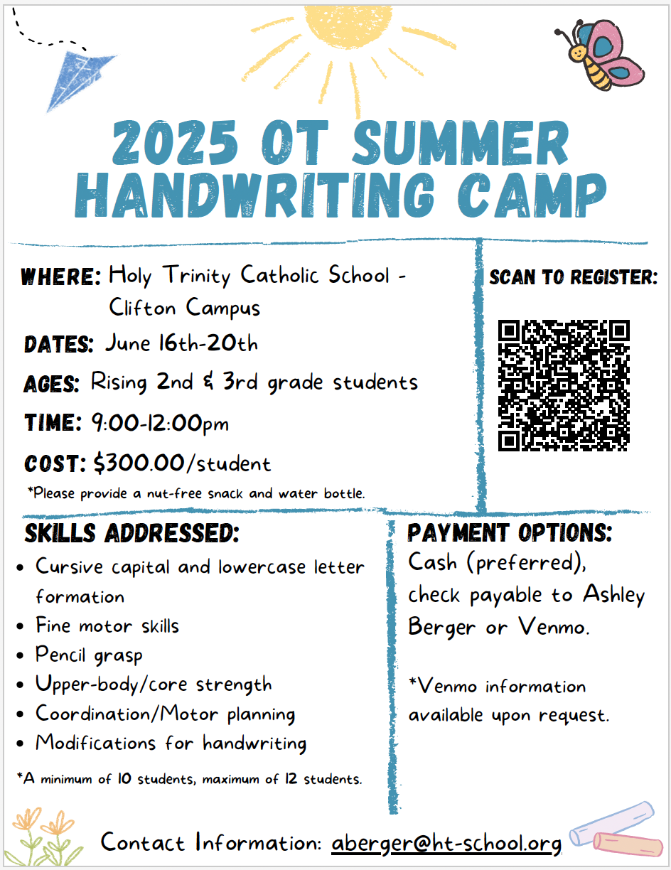

List of Private Providers Outside of Holy Trinity
Organizations for Math:  Mathnasium  https://www.mathnasium.com/stmatthews  The Academy  http://www.theacademyoflouisville.com/  Educational Solutions  https://apluseducationalsolutions.com/  GradePower Learning (Susan Lim)  louisvilleky@gradepowerlearning.com  Club Z! (in-home tutoring)  https://clubztutoring.com/louisville/ | Organizations for Reading:  Langsford Center  https://weteachreading.com/  The Academy http://www.theacademyoflouisville.com/  Educational Solutions https://apluseducationalsolutions.com/  GradePower Learning (Susan Lim)  louisvilleky@gradepowerlearning.com  Club Z! (in-home tutoring)  https://clubztutoring.com/louisville/
Mary Grizzle  Former teacher at Holy Trinity & Langsford Center  Specialty in Reading Grades K-2  3531 St. Germaine Ct.  Home: 895-7098/ Cell: 387-4640  maryfgrizzle@gmail.com | Lynn Schaftlein  Reading Instruction, Orton-Gillingham Trained  Also provides study/organizational skill instruction  Tutors all grades  704-293-5227  schaftlein@aol.com
Grace Henry
Current JCPS middle school math teacher
Bachelors in Middle Level Education - certified in math and social studies grades 5th - 9th
All grade levels - math
Call or text (502) 797-3503
gracehenry2710@gmail.com

