List of Private Summer Tutors at Holy Trinity
**The individual tutors and tutoring services included are simply a list of area resources. Their inclusion here does not constitute or imply the endorsement of Holy Trinity Catholic School. It is the parents’ responsibility to obtain references, cost structure,
policies, etc. from the tutors listed, and select a provider who is a good fit for your child and needs.**
Kelley Powers  Kindergarten Teacher  Masters Degree, LETRS certified  Tutors Grades K-2, reading & math  kpowers@ht-school.org | Julie Melder  Reading Resource Teacher  Masters Degree and Wilson Certified  Tutors Grades K-5 in Reading & Math  jmelder@ht-school.org | Katie Baker  Kindergarten Teacher  Masters Degree, LETRS certified  Tutors Grades K-2, reading & math  kbaker@ht-school.org
Peggy Gray  Kindergarten Teacher  Masters Degree, LETRS certified  Grades K-2 in Reading and Math  pgray@ht-school.org  Wednesdays only | Jennifer Mullins  1st Grade Instructional Assistant  Master’s Degree  1st-3rd  Jmullins@ht-school.org | Allie Blackburn  2nd Grade Teacher  Masters Degree in Education  Tutors grades 2-5, all subjects  ablackburn@ht-school.org
Nikki Allgeier  Office Manager  Associates degree in science  Tutors K-4 all subjects  nallgeier@ht-school.org | Hannah Graham  3rd Grade Teacher  Masters in Teaching  Reading and Math 2nd through 4th  hgraham@ht-school.org | Tiffany Horner  4th Grade Math Teacher  Masters Degree  Tutors Grades incoming 3-7, all subjects  thorner@ht-school.org
Mary French  6th Grade Social Studies/Religion  Masters Degree  Tutors Grades 3-8, all subjects  mfrench@ht-school.org | Nakiah Hafling  6th Grade LA/LIT  Bachelors in Middle and Secondary English Education  Grades/subjects you tutor in: 3-8  nhafling@ht-school.org | Eric Awbrey  7th/8th Grade Social Studies  Masters Degree  Tutors Grades 1-7 all subjects  eawbrey@ht-school.org
Claudia Alfaro  Spanish Teacher  Certified ESOL Teacher  Tutors Grades 4-8, Spanish  calfaro@ht-school.org | D.Dee Hill  Librarian  Certified in Early Childhood-4th  Tutors Grades K-8, all subjects  dhill@ht-school.org | Catherine Barton  Rank 1, Masters in Reading, Masters in Learning and Behavior  Disorders, Retired FCPS teacher 28 years classroom experience  Orton-Gillingham Trained  Tutors K-3 in reading  cbarton@ht-school.org
Ashley Davenport  Director of Student Activities  Masters Degree, Certified in Elem. Ed. and Spec. Ed. – Learning and Behavior Differences;  Tutors Gr. 2-8 & homework asst.  adavenport@ht-school.org | Theresa Bradshaw  Jr. High Instructional Assistant  Bachelors of Science in Occupational Therapy  Tutors Grades 1-6, all subjects  tbradshaw@ht-school.org
OCCUPATIONAL THERAPY  Ashley Berger  Occupational Therapist - HT Clifton School  Private Occupational Therapy Sessions - Grades PreK-8th grade  aberger@ht-school.org | OCCUPATIONAL THERAPY  Peyton Bishop  Occupational Therapy Assistant - HT Clifton School.  Private Occupational Therapy Sessions - Grades PreK-8th grade  pbishop@ht-school.org
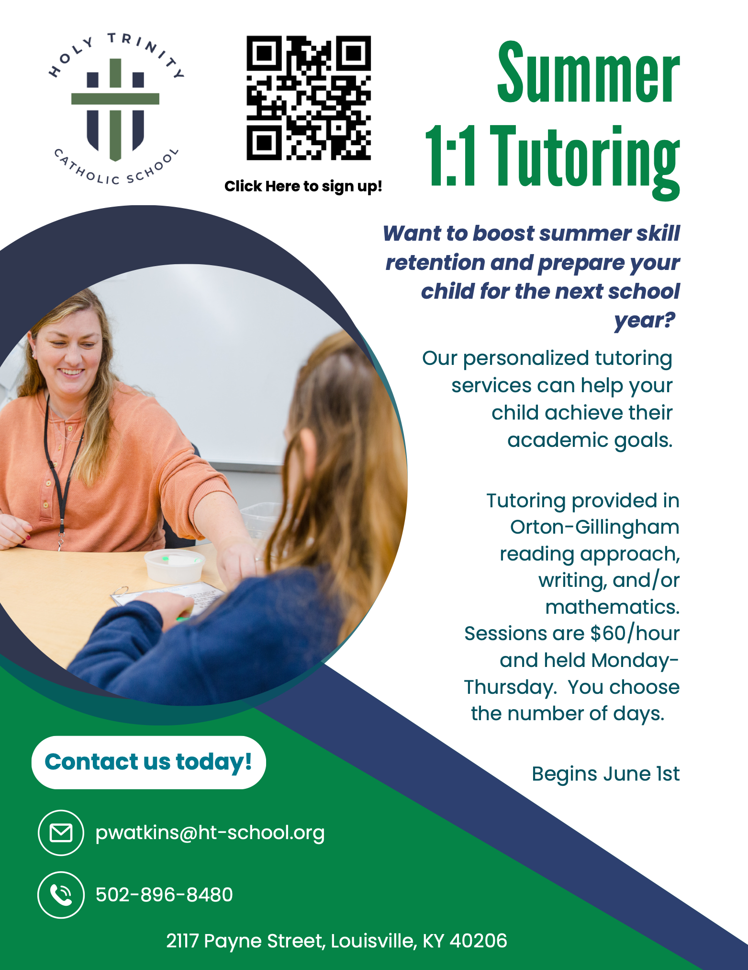

List of Private Providers Outside of Holy Trinity
Organizations for Math:  Mathnasium  https://www.mathnasium.com/stmatthews  The Academy  http://www.theacademyoflouisville.com/  Educational Solutions  https://apluseducationalsolutions.com/  GradePower Learning (Susan Lim)  louisvilleky@gradepowerlearning.com  Club Z! (in-home tutoring)  https://clubztutoring.com/louisville/ | Organizations for Reading:  Langsford Center  https://weteachreading.com/  The Academy http://www.theacademyoflouisville.com/  Educational Solutions https://apluseducationalsolutions.com/  GradePower Learning (Susan Lim)  louisvilleky@gradepowerlearning.com  Club Z! (in-home tutoring)  https://clubztutoring.com/louisville/
Lynn Schaftlein  Reading Instruction, Orton-Gillingham Trained  Also provides study/organizational skill instruction  Tutors all grades  704-293-5227  schaftlein@aol.com | Grace Henry  Current JCPS middle school math teacher  Bachelors in Middle Level Education - certified in math and social studies grades 5th - 9th  All grade levels - math  Call or text (502) 797-3503  gracehenry2710@gmail.com

